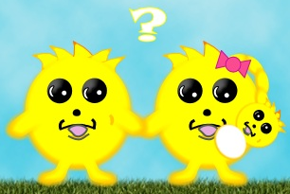
Name: ____________________________________ Class: _____ Date: ______________
Snurfle Meiosis
- Click on Snurfle Meiosis App
- Click on Continue
- Click on Continue
- Click on Meiosis and Genetics Interactive and follow the instructions as you answer the questions.

- When does interphase occur? _________________________________________________________________
- What occurs during interphase? ________________________________________________________________
- Uncoiled stringy DNA is called ________________________________.
- Human cells have _____________ pieces of chromatin.
- Half of your DNA comes from your _______________________ and half from your ________________.
- DNA has _____________________ that determine traits of an organism.
- Different forms of a gene are called _____________________.
- List the 2 alleles for fur color in Snurfles & the letter that represents those alleles? _________________ and _______________.
- ____________________________ is when DNA copies itself and it occurs during ________________________.
- _________________________ are made during meiosis. Examples of gametes are _________ & ____________.
- Meiosis occurs in _____ divisions; Meiosis ____ and Meiosis _______
- List the phases for Meiosis I. ________________, __________________, _________________, ______________
- List the phases for Meiosis II. ________________, __________________, _________________, ______________
- During prophase I the chromosomes __________________ and become ______________________.
- Chromosomes that are the same size and have the same genes are called __________________ _____________
- Each half of a replicated chromosome is called a ____________________________________________________
- Sister chromatids of a chromosome are identical _______________________________.
- The nucleus ________________during prophase.
- Homologous chromosomes pair up during prophase I to form a __________________.
- During metaphase I the tetrads line up in the ____________________ of the cell.
- The homologous chromosomes split up and move toward the opposite ends of the cell during _________________.
- ______ independent cells begin to form during _________________________.
- __________________________ is the division of the cytoplasm to make two new cells.
- The 2 new cells that are formed from Meiosis I are _____________ because they contain half of the chromosome of the original cell that started meiosis.
- At the start of Meiosis I you had 1 ____________ cell.
- Meiosis II must take place because each of our new cells still has too much ______________.
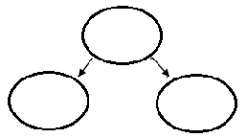
- Draw the chromosomes in Meiosis I. Label the cells as diploid or haploid.
- The nucleus ______________________ during prophase II.
- In Metaphase II the chromosomes line up single file down the __________________ of the cell.
- In ___________________ the sister chromatids split up.
- In Telophase II, _____ ___________ daughter cells are being formed.
- They are called _______________.
- Each newly formed cell will form a ________________________ around the chromosomes.
- The chromosomes ____________________ to form ______________________.
- ____________________________ occurs at the same time at Telophase II.
- At the end of Meiosis II you have made ____ _____________ gametes (sex cells).
- Draw and label the Meiosis Summary.
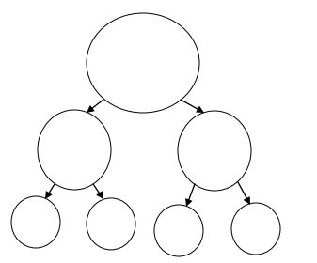
- If the gametes are produced by a female they are called __________________ or _______________.
- If the gametes are produced by a male they are called ________________.
- The _______________ square is a tool that is used to predict possible offspring of a genetic cross.
- The letters on a Punnett square actually represent possible _____________________.
- When sperm and egg join it is called ______________________ which is a fertilized egg.
- Complete the Punnett square to the right.
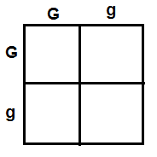
- A _________________ is the genetic make-up of an organism.
- _____________ and ___________ are examples of genotypes.
- A __________________ is the characteristic or appearance of the organism.
- ____________________ & ________________ are examples of phenotypes.
- Dominant alleles are represented by ___________________________ letters.
- Recessive alleles are represented by ____________________________________ letters.
- ____________________________ alleles will show in your phenotype even if it has one copy.
- For recessive traits to show in the phenotype, the snurfle will need ____ copies of the gene.
- __________________________ means an organism has 2 copies of the same allele in its genotype (GG,gg)
- __________________________ means an organism has 2 different alleles in its genotype (Gg, Tt, Rr)
- Click on the chromosome Quandry and follow the directions
- Click on the Meiosis and Genetics Quiz! Answer the questions
- Click on the Score Sheet and record your scores in the table below.
Overall Score | Meiosis | Genetics | Chromosome Quandary | Quiz

