Name: ____________________

Date: _____________________

Period: ___________
Cell Defense
The Plasma Membrane

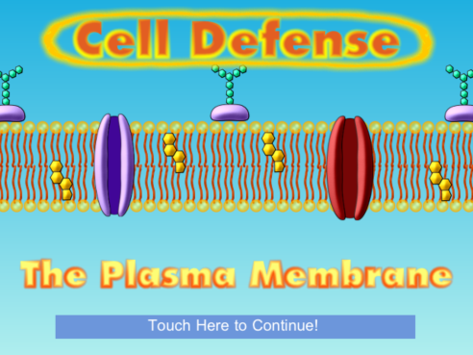
Directions: Read the steps here and all the information on the screen. Follow all the steps carefully filling in all the blanks.

Step 1: Click touch here to begin the app. You want to move to the “Choose Your Challenge!” menu. From the menu choose “Build a Membrane!” Dr. Vial has a vile weapon (note the play on words) that destroys plasma membranes. Without _______ ________________ cells of living things will die because they are unable to maintain _________________________.

Step 2: Zoom in on the plasma membrane. From the “Urgent Message” you learn that phospholipids are a ________________ Head and __ __________ ________ TAILS.
The heads are _______________________________ which means ______________________________.
The tails are ________________________________ which means _______________________________.
The heads face out towards the ________________ and the tails facing ____________ _________.
Draw and label the phospholipid in the box:
Step 3: Repair the phospholipid membrane.
How many phospholipids did it take? _______
Step 4: What do you have to put into
the membrane in order to help stabilize it?
___________________________________ How many did you add? _____
Step 5: What is another word for selectively permeable? _________________________________.
What does that mean? __________________________________________________________________
________________________________________________________________________________________.
Step 6: What 2 molecules easily pass through the membrane? Record why for each.
Molecule 1 | Molecule 2

Step 7: What 3 molecules cannot easily pass through the membrane? Record why for each.
Molecule 1 | Molecule 2 | Molecule 3
What does polar mean?
Step 8: Insert channel proteins into the membrane. Transport substances across the membrane. Note: You can only transport substances using channel proteins until there were
_________________________________________________________________________________________. What is this process called?
Step 9: Moving from ______ to _______ concentration requires the use of energy to _________ substances. This is called ______________________________ transport and uses: (place answer in table)
1. | 2.  Which is cell ______________
Step 10: Carbohydrates are like identification badges. Cells that have different membrane carbohydrates do different ________________. The immune system uses the carbohydrates to _____________________ that your cells belong to ________ and are not ______________________, ____________________, or other foreign cells.
What does the immune system do to foreign invaders?
What kind of cell does this?
After this cell passes by a few times. Double tap the “MENU” button.
Step 11: Next take the “Membrane Structure Challenge!”
Step 12: Take the “Diffusion Challenge!”
Step 13: Take the “Energy and Transport Challenge!”
How many ATP did you use? ______ What type(s) of protein(s) were used? __________________
_________________________________Explain when each type was used._______________________
__________________________________________________________________________________________
Step 14: Take the “Osmosis Challenge!”
What is Osmosis? _________________________________________________________________________
What is the name of the special proteins that let water pass through? ______________________
Is this passive or active transport? ______________________________________
Step 15: From your Scores Sheet record:
Lab Score (% correct): ____________

Number Correct: _______

Number Incorrect: _______

